**SoCal Media Link**   
Facebook   
<https://www.facebook.com/profile.php?id=61564981378617>

LinkedIn  
<https://www.linkedin.com/company/bright-studio-ltd-bd/?viewAsMember=true>

Instagram

Twitter   
<https://x.com/BrightStud14966>

YouTube  
[www.youtube.com/@BrightStudioLtd](http://www.youtube.com/@BrightStudioLtd)

**Address**  
**BANGLADESH BRANCH**

Address: Dhaka, Bangladesh

Call:

Website: www.brightstudioltd.com

Email: info@brightstudioltd.com

Skype: [brightstudioltd24@gmail.com](mailto:brightstudioltd24@gmail.com)

**AUSTRALIA BRANCH**

Address: Sydney, Australia

WhatsApp Number:

Email: [brightstudioltd24@gmail.com](mailto:brightstudioltd24@gmail.com)

**SWEDEN BRANCH**

Address: Stockholm, Sweden

WhatsApp Number:

Email: [brightstudioltd24@gmail.com](mailto:brightstudioltd24@gmail.com)

## HOME VEDIO

## PROFESSIONAL PHOTO EDITING AND RETOUCHING SERVICES

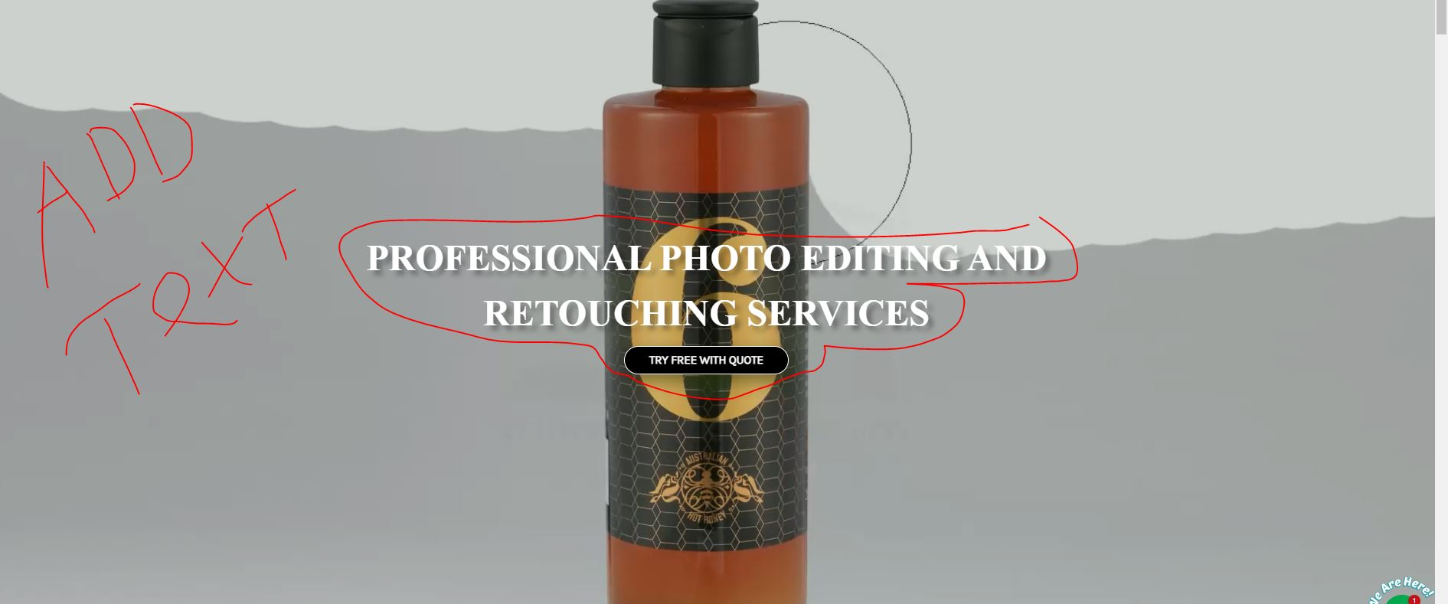

## PHOTO RETOUCHING SERVICE PROVIDER

## Our outstanding services will help your Business Growth

## 

## 

## LET’S INTRODUCE OURSELVES Bright studio ltd is an IMAGE POST PRODUCTION SERVICE PROVIDER COMPANY. It is also known as the studio of experienced Graphics Designers started its journey in the Image Editing Industry in 2023. The objective of Bright studio ltd is to provide any kind of high-quality design, advertisement, and E-commerce Image editing services at a reasonable cost and time-saving. We are always motivated by the efficient work we do for our clients. We take challenges for our clients to fulfill their requirements. Our goal is to satisfy our clients through our best services. We work mostly with Photographers, Photography Agencies, Online shops, and Brands shops all over the world. Our image processing is full as per European Standards. This studio is based in Bangladesh. At present, we have 100+ experienced (4 to 10 years) designers who are working 24/7 & 365 days for our clients to meet the deadline/turnaround time, We even work on all holidays if necessary.

# Price examples

Please note that the prices below are for guidance only. For all clients, we calculate a price per image based on the specific job task.

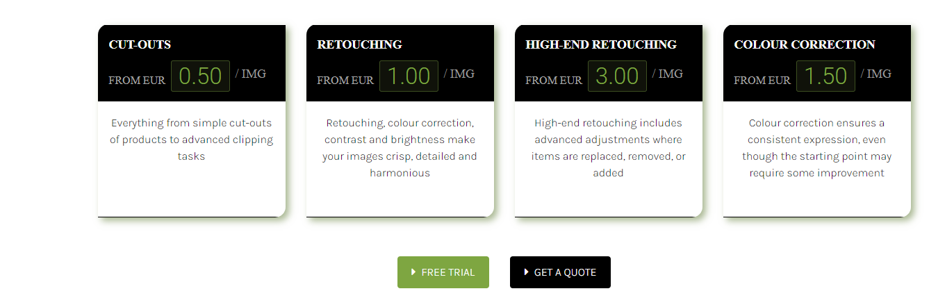

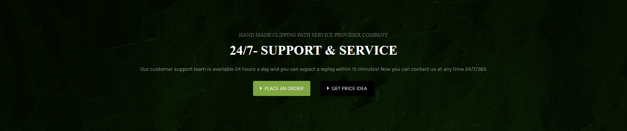

**WE ARE SPECIALIZED IN HIGH-QUALITY E-COMMERCE IMAGE EDITING SERVICES**

# Our Recent Works

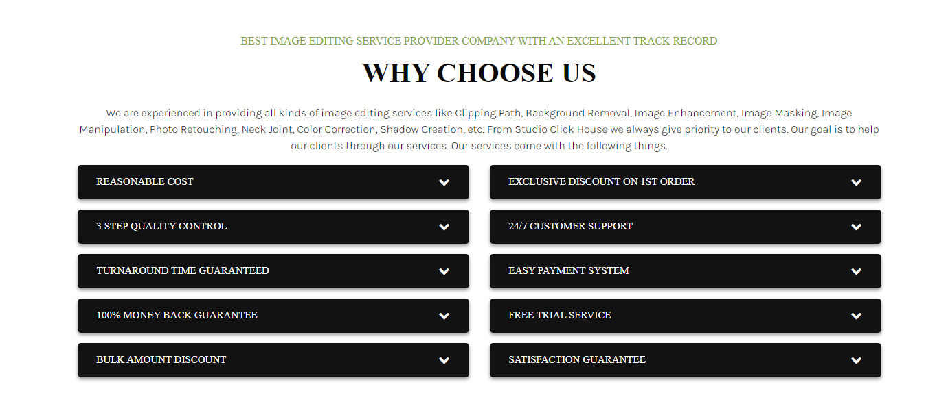

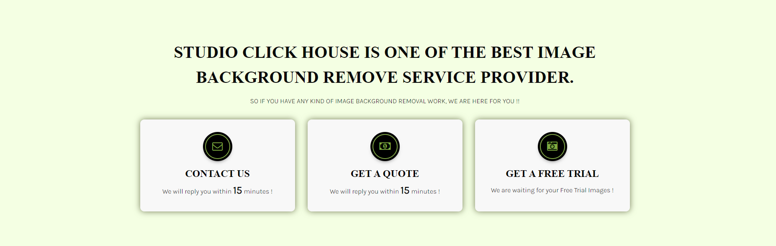  
  
  
  
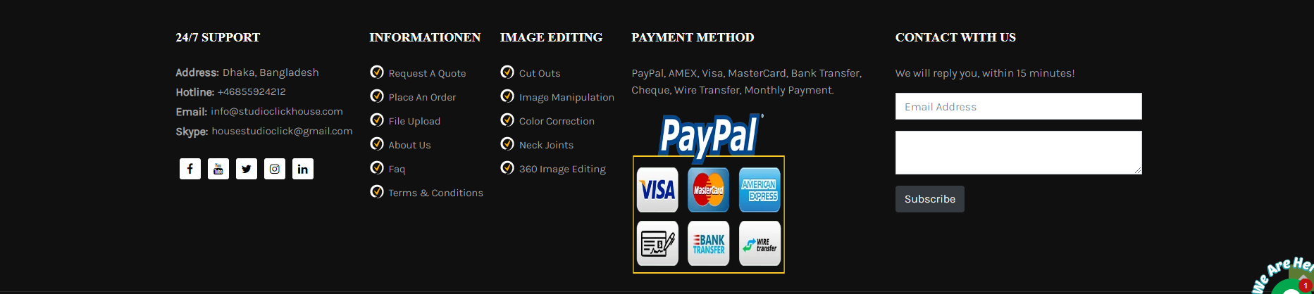

**WE OFFER PROFESSIONAL PHOTO EDITING AND RETOUCHING SERVICES IN A QUICK TIME**

# PRICING AND COMPLEXITY

The complexity of the object to be isolated and any further processing affects the cost per image. Bright Studio Ltd categorizes photographs into one of a few groups in order to determine the final cost of a service. Depending on the service you require, the complexity of the photographs, and the number you have, the cost of the services we provide vary from job to project. To give you an idea, our Photoshop clipping path prices start at €0.50 per image, and we provide substantial discounts for large orders. Upon examining your projects, we prefer to present you with reasonable costs if you require any more services or more. Bulk Images?  
  
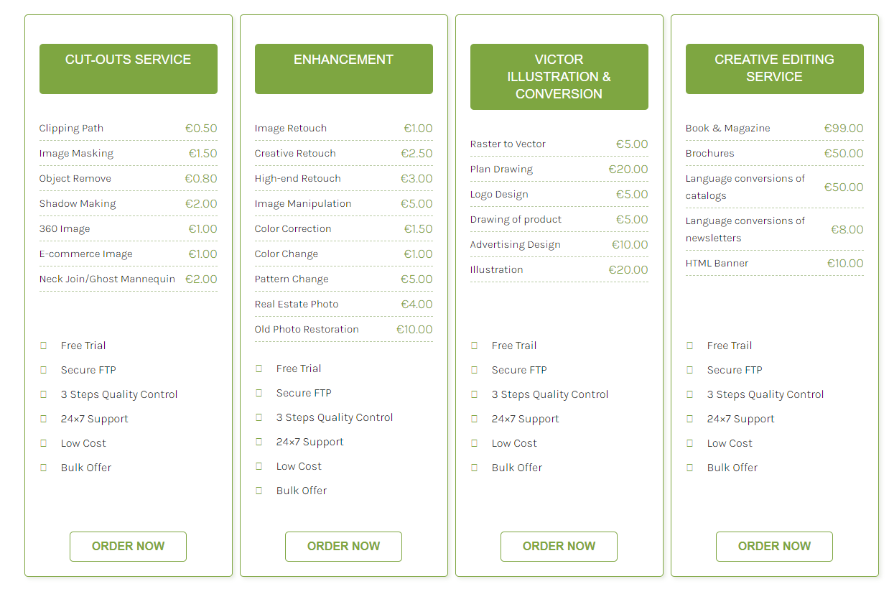

## Contact Us

###### **WE ARE KNOWN FOR THE BEST IMAGE EDITING AND BACKGROUND REMOVAL SERVICE PROVIDER WITH**

# 24/7- SUPPORT & SERVICE

We appreciate your desire to collaborate with Bright Studio Ltd. Please answer the questions below so that we can evaluate your project and requirements more thoroughly. Even though we're sticklers for specifics, we understand that you might not have all the information, and that's totally fine. Just fill out what you can, and we can talk about the rest later.

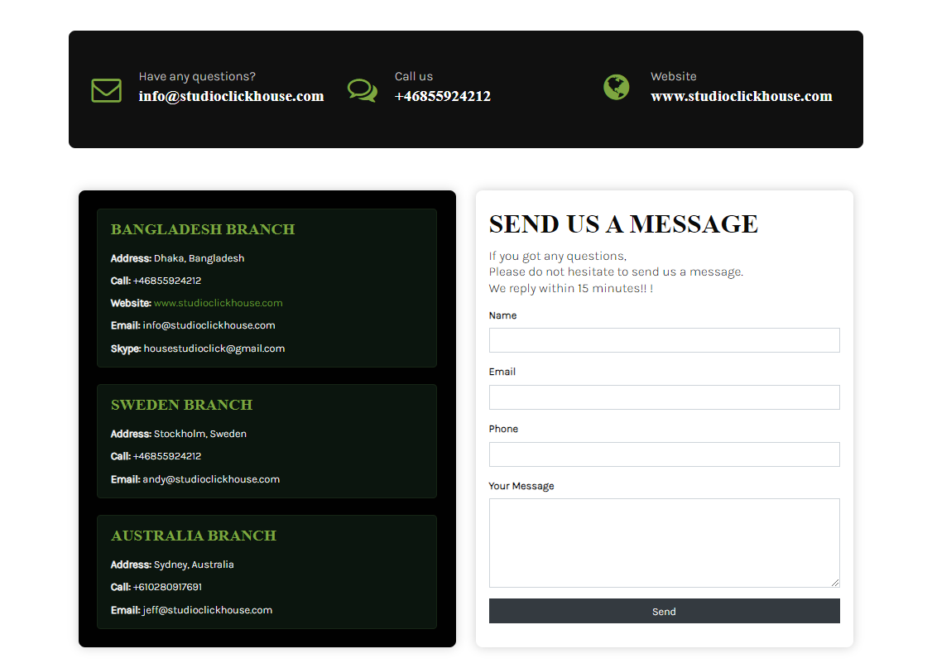  
  
<https://studioclickhouse.com/>